# **Racoon 203: Infil/Exfil**

### Personnel:

* 1 Instructor
* 1 Rook or Raven
* 8 Students
* 5 OPFOR - 4 on foot, 1 in vehicle

### Equipment:

* Instructor:
  + Spartan is mandatory
  + Any other Atlas platform
* Rook:
  + C2 or M2
* Students:
  + Standard racoon equipment
    - Must be warm enough for Yela
  + 2 Primaries. (Ex. Rifle + sniper)
  + STV or cyclone variant.
* OPFOR:
  + Non-racoon gear
  + 2 Primaries (Ex. Rifle + sniper)
    - No P6 or scalpel
* If a TA attends, have them bring a medical vehicle.

## 

## **Location**

Jumptown on Yela

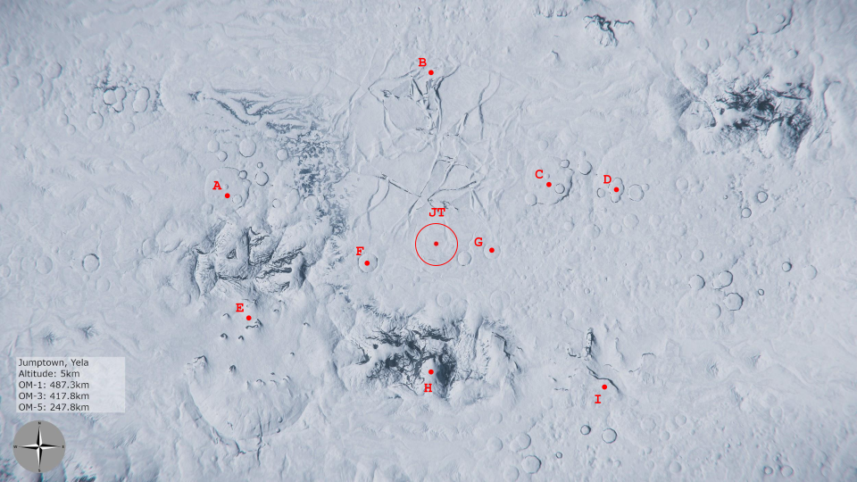

How to get there:

* Jump to Security Post Opal.
* Fly for 233km at a heading of 008.
* Triangulation:
  + OM-1: 487.3km
  + OM-3: 417.8km
  + OM-5:247.8km
* Other options:
  + <https://www.youtube.com/watch?v=y5gTjucVquA> 1min guide to locate JT. **Requires sunlight.**
    - <https://www.reddit.com/r/starcitizen/comments/xn6spu/finding_jt/> Text guide of same method.

## **OPFOR/Rook Briefing**

* Go over timing and class schedule
* Provide the map of the AO: <https://i.imgur.com/Zsw4UZ1.png>
  + There is a 1km diameter circle around JT for reference.
* For OPFOR:
  + Play at 100%. Don’t pull your punches. However, no double taps, no revives.
  + Encourage colorful and crazy armor and kit outs. Try hard to NOT look like a Racoon. Use different kinds of weapons. NO Railguns, NO Specials. Primary weapons only.
    - Banned snipers for OPFOR: P6, Scalpel.
  + OPFOR are to deploy ASAP when the Herc lands at the AO.
  + One OPFOR will be inside one of the Atlas platforms, in the opposite Atlas platform of the instructor.
    - If this OPFOR isn’t incapped when the students call the extraction, they can use the Atlas platform to attack the class. This includes attacking the Herc.
  + Ask them to be **prepared to provide feedback** when asked by the instructor (positive and negative).
* For the Rook:
  + At the beginning of the combat exercise, the Rook is to establish the vehicle deploy order for students to follow.
  + Land in a cardinal direction. Communicate which direction with the students and give a rough direction to the objective.
    - If a student loses their bearings, they can request assistance from the Rook. The rook is to do a flyby near the student’s position. They are to fly toward a cardinal direction and communicate this direction to students.
  + Reinforce that students aren’t to get jumpy and bump each other inside the Herc to avoid possible explosions.
* Share which voice channel will be used for OPFOR Comms and which SRS frequency to use.
* Inform Shadow Instructors to **prepare for introductions and to provide feedback**.
* **OPTIONAL (Recommended):**
  + Prior to class, fly to JT. Bed log. During the OPFOR meeting, have 1 OPFOR or TA QT to your location. Have them bed log on site for an easy QT beacon for the class.

## **Intro and Departure**

* Pull the Herc.
* Be clear about the loadout requirements. No inspections will be done. If a student brings improper gear, that is their problem.
* All participating Skunks are to load into the Herc.
  + Respect Elevator Protocol.
  + The students are to line up in yellow lined areas near the elevator of the Herc cargo hold.
  + OPFOR are to take the turrets and upper floor.
* The Herc is to then head to ArcCorp Mining Outpost 157 for vehicle pulls.
* Introduce yourself
* Introduce Shadow or TA instructors
* Discuss Initial communications protocol
  + Speak in the third person.
  + Speak with discipline and precision.
  + Respect the universal shut up callout: “**CLEAR COMMS”** and **“BREAK, BREAK, BREAK”**

## **Student Briefing During Travel to Outpost**

* Explain the purpose of this class. What it is. What it is not.
  + “This is Racoon 203. In this class we will be learning about proper dropship procedure and vehicle deployment/usage *as a racoon*. While you may think that it's as simple as grabbing a C2 and loading/unloading it how ever you’d like, this is not the case. The purpose of this class is to get racoons, especially newer ones, familiar with the vehicles that you will commonly use and be around in events such as Skunkopoly.”
  + “This is not a Rook class, nor a Rhino one. We’re not teaching you how to be pilots or tankers. We’re teaching you how to be effective racoons when interacting with them.”
* Pair students in teams of two. Explain that they will be partnered up for the rest of the class.
* Discuss OPFOR - Explain that they are playing at 100%. Make a point that the students need to be prepared for a tough fight.

## **Vehicle Prep at Mining Outpost**

* Once the class arrives at the outpost, the Rook will drop off the class and move just outside of armistice to avoid crimestat if improper loading occurs.
* The instructor will pull the Atlas platforms and the OPFOR are to drive them up to the Herc. Do not load them.
  + Explain the bug that vehicles stored in other vehicles can become inactive during relogs.
* Choose 4 students and have them pull their choice of small rover. (i.e. Cyclone or STV)
* Discuss proper loading procedure:
  + Atlas platforms (and tanks) are to be loaded front first into the rear of the Herc down the center of the ship, and unloaded in reverse. The reason for this is that the turrets on the Centurion and Ballista can clip into the Herc causing damage or ship destruction. Safety first.
    - Novas should have their main gun turned off. While powered off, the gun goes into a low-profile mode.
  + Small rovers are more flexible. These are always to be loaded on the sides of the Herc interior. Passenger side against the walls. There should be enough room for the driver to get in and out.
* Have the students load the Herc with:
  + 2 Atlas platforms (Spartan preferred, then Ballista, and Centurion)
  + 4 Cyclones or STVs.
* Go over proper transport procedure:
  + OPFOR are to load into the Atlas platforms
  + Students into their respective rovers.
  + They are to remain in place during transport.

## **Exercise Briefing During Travel to AO**

* The Rook is to fly directly to the objective location for OPFOR deployment.
* Revives are allowed, double taps are not.

### **Exercise Objectives:**

* Infil with cyclone/STV
  + Eliminate all OPFOR **(optional)**
  + Recover the instructor with **at least one** Atlas platform
* Exfil with the Atlas platform(s)
  + Locate extraction point
    - The Rook is to be called in to extract at the exfil point. They are to sit outside the AO during the exercise otherwise.
  + Load captured OPFOR vehicle in Herc.

### **Talking points**

* What is the proper distance and location to abandon personal transport?
  + ~1km
* What are the audio ranges of cyclone, stv, and atlas?
  + STV
    - Engine: ~15m
    - Wheels: ~170m
    - **Note:** STV is almost silent when driving in a straight line. However, any time the STV accelerates, there is an audio sfx that can be heard for a short period. This effect is more prominent when using sticks and pedals or driving over rocky terrain.
  + Cyclone
    - Engine: ~80m
    - Wheels: ~200m
  + Ballista
    - Engine ~325m
    - Wheels ~350m
* As of 3.17, hot drops are more likely to get you killed than to deploy quickly.
* Deployment Pro-words:
  + Prepare to drop
  + Drop, drop, drop
* Identify landmarks to better understand the map.
* Expand

## **OPFOR Deployment at AO**

* On arrival to objective, OPFOR are to deploy the Atlas platforms and take defensive positions.
* Explain and demonstrate how to break into any enclosed vehicle.
  + Damaging vehicle doors sufficiently will cause them to open. Even punching doors open is possible.
  + Use of an R-97/FS-9 is highly recommended due to burst damage.
  + Do not attempt to shoot open doors at range, it must be done point blank to bypass shields.
* Post a map of the AO to the training channel
  + Allow time (no more than 5 minutes) for the students to plan their strategy.
  + After planning is complete, select one student to act as squad lead.
    - The assigned lead will decide the infil and exfil points. The Rook will confirm.
      * Ex. “I’d like to use point A as an infil point and point B as an exfil point."
      * The same point cannot be used as both an infil and exfil point.
    - Let them know that in the case of a squad lead being incapacitated, the lead is to select another student to take their place.
* The instructor will deploy with the OPFOR to double as an objective marker.
  + Inform the students that once the Rook lands at the infil point, **the exercise begins.**

## **Student Deployment and Exercise Start**

* Once the Rook lands, all students are to deploy.
  + The Rook will instruct the class on how to leave the Herc properly.
    - One at a time from the back or front.
  + Student drivers should call out when they’ve exited the Herc.
* How they decide to complete the objective is up to them.
* If a student loses their bearings, they can request assistance from the Rook. The Rook is to do a flyby near the student’s position. They are to fly toward a cardinal direction and communicate this direction to students.
* Timer - Set an appropriate time limit taking into account the total 2 hr class time.

## **Student Exfil and Exercise Completion**

* Once the students have captured the objective, they are to head to the exfil location and extract with the Rook.
* OPFOR can pursue the students with the other Atlas platform if any are still active.
* If the students get wiped, they **will** still be granted credit for the course, but the feedback section of this course **will** need to be more extensive.

## **Trip Home Briefing**

* The Rook is to take everyone back to CRU-L1.
* Feedback Session – Squad leads, OPFOR, then Instructor(s).
* Ask each member to list one thing they learned and one thing they may want to improve on.
* When arriving at CRU-L1, have all recruits line up under the arrivals sign to take a graduation picture. Make sure global chat is off, and ensure name tags are visible.

## 

## **Class Notifications and Communications Cadence**

### **Class Sign-Up:**

**Racoon 203: Infil/Exfil**

**Muster:** UTC DATE AND TIME HERE ( <HAMMER TIME HERE> YOUR TIME ) at CRU-L1

**Main Instructor:**

**Shadow Instructor:**

**Dropship Pilot:**

Racoon 203: Infil/Exfil focuses on proper drop ship procedure, vehicle deployment and extraction, and outdoor engagements with vehicles. The class will take around 120 minutes.

**Prerequisite:** Racoon 101

**Required Equipment:** Standard racoon loadout (see pinned post in the #⭕🦝racoons).

This class takes place on Yela. Dress appropriately.

Two primary weapons (ex. Rifle and sniper). NO HEAVY WEAPONS.

1 cyclone (any variant) or STV purchased (preferably with aUEC) prior to class.

Be at muster with all equipment 15 minutes before class starts. Once the class begins there will be no late arrivals admitted without prior instructor's approval. Additionally, please ensure that once you are admitted to the class or selected as an alternate, you send a friend request in-game to the instructor (@Instructor) to ensure a timely start to our training.

**Class Roster**

1.

2.

3.

4.

5.

6.

7.

8.

**Alternates**

A1.

A2.

A3.

A4.

**OPFOR (Signup in #🟠opfor-request )**

O1.

O2.

O3.

O4.

O5.

Please Sign up by posting in this thread.

### **Notification of OPFOR Briefing**

OPFOR and Rook Volunteers - (@OPFOR) - Please join me on channel: training-voice-# 30 minutes before the start of training.

### 

### **Eve of Training Day Reminder**

CLASS MEMBERS

We’ve got one short day before the class. As mentioned, this class will take about 120 minutes. This is a huge investment for everyone and it is my intention to make sure you walk away having learned something, had a good time, and get you one step closer to Racoon Specialist. I have just a few basic asks:

BEFORE CLASS:

1. Please have your equipment stored and your character logged off at CRU L1 before the class. In addition to the standard uniform, please bring a sniper and spare oxypens. We are launching <Hammertime> sharp. If you are tardy, then an alternate will take your slot.

2. Be logged into the LIVE PU and at menus at time of muster.

3. Please ensure that you have joined the "training-voice-2" DISCORD channel under the training tab 15 minutes prior to class start. That is where we will communicate throughout the class.

4. Please be sure to send me a friend request in-game (the name is the same: Instructor), so that I can start creating the party ahead of time as you all join.

DURING CLASS:

1. Please be respectful to the others in the class.

2. Don’t talk over the instructor(s). Again, it's about respect. We are happy to take questions, but please wait for breaks in the comms.

3. In short - Just don't be a jerk :slight_smile:

4. Most of all - Have fun!

### **Class Completion:**

Congratulations to today’s Racoon 203: Infil/Exfil class!

The following Racoons went through the gauntlet and have earned their 203 qualification: ENTER CLASS HERE

Special thanks to the OPFOR that gave a proper challenge to today’s class: ENTER OPFOR HERE

Good job everyone!